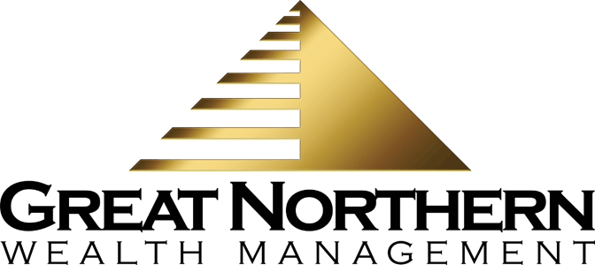

8785 N. Government Way / PO Box 2813, Hayden, ID 83835   
208.762.7773 or 888.862.8353   
skuebler@gnwealth.com  
www.gnwealth.com

Shayne D. Kuebler, Investment Advisor



**Quarterly Economic Update  
Fourth Quarter 2024**

2024 was another strong year for equity investors. While not as good as the year’s first three quarters, the fourth quarter still finished with positive returns, more record highs, and an optimistic outlook toward 2025. Historically, equity markets have advanced in the fourth quarter and after a series of ups and downs, they finished ahead of where they started.

Equity markets entered the quarter with strong momentum and after the election results in early November, they responded favorably. They were also helped during the quarter by continued monetary easing from the Federal Open Market Committee (FOMC).

The S&P 500 index ended 2024 with nearly the same results as 2023. For 2024, the S&P 500 closed the year with a gain of more than 23% (24.23% in 2023) and had 57 record closes. The Dow Jones Industrial Average (DJIA) ended the year up almost 13% (13.7% in 2023). *(*[*www.macrotrends.net*](http://www.macrotrends.net)*; cnbc.com 1/2/25)*

The S&P 500 entered the fourth quarter with impressive annual returns but stumbled to the finish line and produced the year’s lowest quarterly return of approximately 2.0%. The DJIA was up less than 1% during the fourth quarter. (*cnbc.com 1/2/25)*

The Fed reduced interest rates three times in 2024. During the fourth quarter, the Fed implemented two interest rate drops, one in November and one in December, thus concluding the year with three interest rate cuts in a row.

In November, the unemployment rate was 4.2%, and wage growth increased by 0.4%. The data from these two key economic indicators is closely monitored by the Federal Open Market Committee (FOMC) to help inform the Fed when making monetary policy decisions.

While some analysts are optimistic, many are citing that the upcoming year will bring new and long-standing issues that could affect the U.S. economy. A new administration with proposed policy changes, monetary easing, and continued geo-political unrest are just a few matters that will bring uncertainty to equity markets.

**KEY TAKEAWAYS**

* 2024 was a robust year for equities and ended with positive returns.
* The Fed reduced the federal funds rate range three times in 2024, with two being in the fourth quarter.
* Inflation pressures continue to be stubborn, with November clocking in at a 2.7% increase compared to a year earlier.
* Bonds present a reasonable option for those looking to diversify their portfolio while including a less volatile alternative to equities.
* 2025 brings a host of challenges, including proposed tax law changes, potential tariffs, monetary policy changes, stubborn inflation rates, and geopolitical issues, which can create uncertainty and market volatility.
* Maintaining the consistency of a well-devised, long-term focused plan has historically served investors well.
* ***We are here for you to discuss any questions or concerns you may have.***

**New administration:** Elected President Trump has promised to bring changes when he returns to the Oval Office. How these changes will affect the U.S. and global economies is yet to be seen.

**Monetary policy changes:** While the Fed did reduce interest rates in 2024, their outlook for 2025 was more hawkish as of December. The Fed has a goal of 2% inflation but also maximum employment and in their December FOMC statement signaled that rate cuts might slow down or pause.

**Continued geo-political concerns:** The Russia-Ukraine war continues, and conflict in the Middle East remains. In addition, proposed tariffs on imports from foreign countries could directly affect equities and the U.S. economy.

As your financial professionals, we are committed to keeping you aware of any changes and activity that could directly affect your unique situation. **Our goal is to continuously review our client’s investments and confirm they align with their time horizon, risk tolerance and goals.**

**Inflation & Interest Rates**

Federal funds interest rates started 2024 at a range of 5.25% to 5.5%, remaining steady until September. During the last four months of the year, the Federal Reserve began a campaign to ease monetary policy and lower interest rates. They started in September with a rate reduction of 50 basis points, followed by 25 basis point reductions in November and December. The federal funds rates finished the year at 4.25% to 4.5%. Equities responded favorably to the first two rate cuts, but in December, they took a tumble due to the Fed’s forecast which significantly pared-back interest rate cuts in 2025. At the September FOMC meeting, they originally expected four rate cuts in 2025. At the December meeting, this forecast was cut in half. As of December, the Fed is now forecasting rates to be reduced by 0.50% in 2025.

Uncertainty about interest rates persists as we move into 2025. The Federal Reserve is committed to their mandate to maintain strong employment rates while striving to return inflation to its target of 2%. They will continue to monitor key indicators to determine their approach to interest rates and are prepared to adjust their monetary policy stance if necessary.

In November, the consumer price index (CPI) recorded its largest increase in seven months, rising by 0.3%. The core CPI, which excludes food and energy prices and is often viewed by economists as a better gauge of future inflation, also increased by 0.3%.

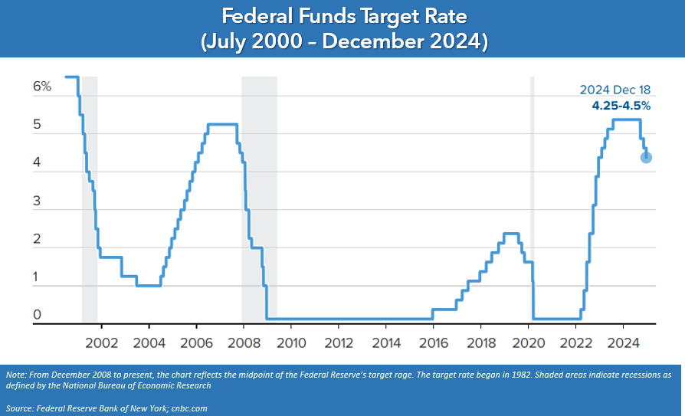

**Interest and inflation rates movements can bring uncertainty for equity markets and therefore we will continue to stay apprised of these key economic indicators.**

**The Bond Market and   
Treasury Yields**

Bonds have an inverse relationship with interest rates—when one goes up, the other usually goes down. After December’s Federal Open Market Committee meeting, treasury yields rose due to the news that fewer rate cuts were anticipated for 2025. This shift in outlook prompted investors to prefer longer-term treasuries and triggered a wave of selling mid-term U.S. Treasurys, driving some bond prices lower and yields higher.

On December 31, the 10-year note was 4.58%, higher than at the end of the third quarter, when it reached 3.81% and higher than the 3.95% it started the year with. The 20-year treasury ended the fourth quarter at 4.86% and the 30-year note closed at 4.78%. Treasury yields at the end of 2024 ended close to multi-decade highs, even with interest rates forecasted to continue falling in 2025. If everything unfolds as expected, this could make bonds, which historically have lower volatility than stocks, a more appealing option as a stable alternative to cash, as well as a hedge against market volatility. On the contrary, interest rates could stagnate if inflation remains belligerent or even reaccelerates. *(Source: treasury.gov)*

**Bonds can be a part of a well-diversified portfolio and we consider using them for clients based on each client’s unique situation. Please remember that while diversification in your portfolio can help you pursue your goals, it does not ensure a profit or guarantee against loss.**

**Investor’s Outlook**

Looking ahead to 2025, investor sentiment remains hopeful and there is a mix of optimism, anticipation and caution. Despite moments of wavering, the U.S. economy has experienced impressive growth, and many believe the current bull market will continue. Key factors such as low unemployment rates, slowing inflation, strong corporate earnings, monetary easing, investor enthusiasm for Artificial Intelligence (AI), and significant market returns have kept investor confidence high. Fears of a recession, while still around, have reduced, as the Federal Reserve continues to fight inflation without slowing down economic growth.

Moving into 2025, a major question is the direction of the U.S. economy and economic growth. The new year will bring changes that could potentially increase volatility. Analysts have mixed outlooks for the markets in 2025. Many are optimistic about a continued market rally. However, on the other end, some are concerned that equities are highly priced and could see some setbacks.

Investors have enjoyed strong annual returns in 2023 and 2024: both up over 20%, compared with the long-run average of about 10%. History teaches us that after that kind of run, you need to be prepared for a possible pullback. Also, valuations of some leading equities are historically high, which is another indicator that it could be more likely that equities will experience a pullback sometime during 2025. Having said that, momentum is also high and long-term investors never want to be caught trying to time equity markets.

When the S&P index falls more than 10% from a recent high, it is said to have entered "correction" territory. The term “correction” is used because historically the market drop often "corrects" and returns equity prices to their longer-term trend. There have been 24 market corrections since November 1974. They historically happen on average about every 18 months. The S&P 500 did not experience a correction in 2024. The last 10% slide took place in October 2023, according to Dow Jones Market Data.

Analysts say that corrections are healthy and even necessary for bull markets.of the so-called froth in the stock market, where prices run up too dramatically and get ahead of themselves. Analysts also share that a correction isn’t necessarily something to dread. Most strategists are still predicting solid earnings growth for equities in 2025. With that backdrop, most analysts project stocks will head higher, even if there are some bumps in the road.

**So, what should investors do?**

One of the best exercises for investors is to revisit their time horizons. Equities are mainly long-term investments and investors should be prepared to hold equity positions for at least five years or more. The goal is to potentially allow enough time to recoup any downfalls that might occur. A well-disciplined plan incorporates the fact that equities do not move in a straight line and the benchmark for investment returns is long-term.

Remember, it is important to resist the emotional temptation to deviate from your long-term strategy. While we can all analyze, speculate and theorize, trying to predict short-term market movements is always challenging and difficult; therefore, we prefer to rely on a well-planned, long-term strategy that considers market volatility, your time horizon, and risk tolerance.

Our goal is to exceed your expectations. We take pride in offering a high-level service that includes consistent and meaningful communication throughout the year.

**As a valued client, we want you to know that we are here for you. If you have questions about your investments, please call our office and we can schedule a review of your portfolio.** **Please keep in mind that there are often many factors to consider when altering anything in your financial plan, such as tax implications, increased risk, and changes in your time horizon.**

**We appreciate the trust and confidence you place in our firm, and we look forward to serving you in 2025 and beyond.**

***We want to help others like you!***

**Many of our best relationships have come through introductions from our clients. We would be honored if you would:**

* Add a name to our mailing list.
* Share our reports with a friend or colleague.
* Introduce us to someone we can help.

**Please call** **us at** **(208) 762-7773, and we’d be happy to explore how we can help them with their financial goals!**

Securities and investment advisory services offered through **Osaic Wealth, Inc**. member FINRA/SIPC.  
**Osaic Wealth** is separately owned and other entities and/or marketing names, products or services referenced here are independent of **Osaic Wealth**.

Note: The views stated in this letter are not necessarily the opinion of **Osaic Wealth, Inc**, and should not be construed, directly or indirectly, as an offer to buy or sell any securities mentioned herein. Investors should be aware that there are risks inherent in all investments, such as fluctuations in investment principal. With any investment vehicle, past performance is not a guarantee of future results. Material discussed herewith is meant for general illustration and/or informational purposes only, please note that individual situations can vary. Therefore, the information should be relied upon when coordinated with individual professional advice. This material contains forward-looking statements and projections. There are no guarantees that these results will be achieved. All indices referenced are unmanaged and cannot be invested into directly. Unmanaged index returns do not reflect fees, expenses, or sales charges. Index performance is not indicative of the performance of any investment.

The S&P 500 is an unmanaged index of 500 widely held stocks that is general considered representative of the U.S. Stock market. The modern design of the S&P 500 stock index was first launched in 1957. Performance prior to 1957 incorporates the performance of the predecessor index, the S&P 90. Dow Jones Industrial Average (DJIA), commonly known as “The Dow” is an index representing 30 stocks of companies maintained and reviewed by the editors of the Wall Street Journal. Past performance is no guarantee of future results. CDs are FDIC Insured and offer a fixed rate of return if held to maturity. Due to volatility within the markets mentioned, opinions are subject to change without notice. Information is based on sources believed to be reliable; however, their accuracy or completeness cannot be guaranteed.

There is an inverse relationship between interest rate movements and bond prices. Generally, when interest rates rise, bond prices fall and when interest rates fall, bond prices generally rise. There is no guarantee that a diversified portfolio will enhance overall returns out outperform a non-diversified portfolio. Diversification does not protect against market risk.

Sources: [www.macrotrends.net](http://www.macrotrends.net); cnbc.com; treasury.gov; bigcharts.com; Department of Treasury; Contents provided by the Academy of Preferred Financial Advisors, 2025©